Jan 9 = 1, Jan 20 = 2, Mar 7 = 2, Mar 22 = 1, Apr 4 = 3, Apr 20 = 4
Jun 8 = 4, Jun 27 = 3, Aug 22 = 3, Sep 4 = 4, Sep 16 = 5, Sep 27 = 6
Oct 10 = 7, Nov 25 = 7, Dec 6 = 6, Dec 15 = 5, Dec 23 = 4

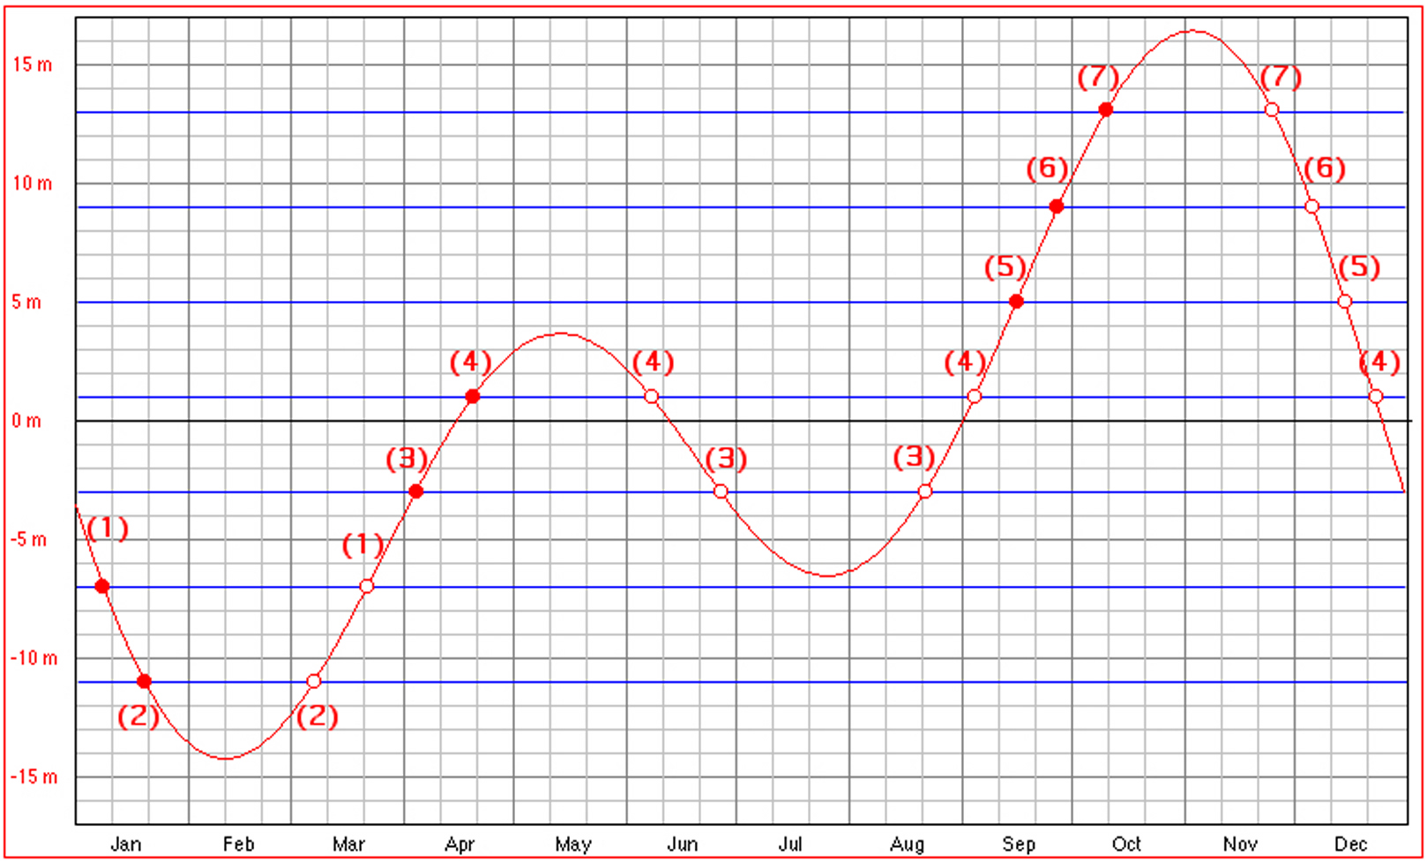
Equation of Time

